BEACONHOUSE NATIONAL UNIVERSITY


LAB 5

Name: Saad Mughal
BNU ID: F2023-009

Total Marks: /20
Due Date: 11 Mar, 2025

Lab Manual
For
COAL(SEC_B)
Course Instructor | Ms. Nimra Abbas
Lab Instructor | Ayesha Seher
Semester | Spring 2025

Problem No.1:
Perform a subtraction operation, and store the result accordingly. Initialize the AX and DX registers with the immediate values 1234h and 5678h, respectively. Subtract the value in the AX register from the value in the DX register and store the result in DX.
Solution:
.MODEL SMALL
.STACK 100H
.DATA

.CODE
MAIN PROC
MOV AX,1234H
MOV DX,5678H
SUB DX,AX
MAIN ENDP
END MAIN
Screenshot:
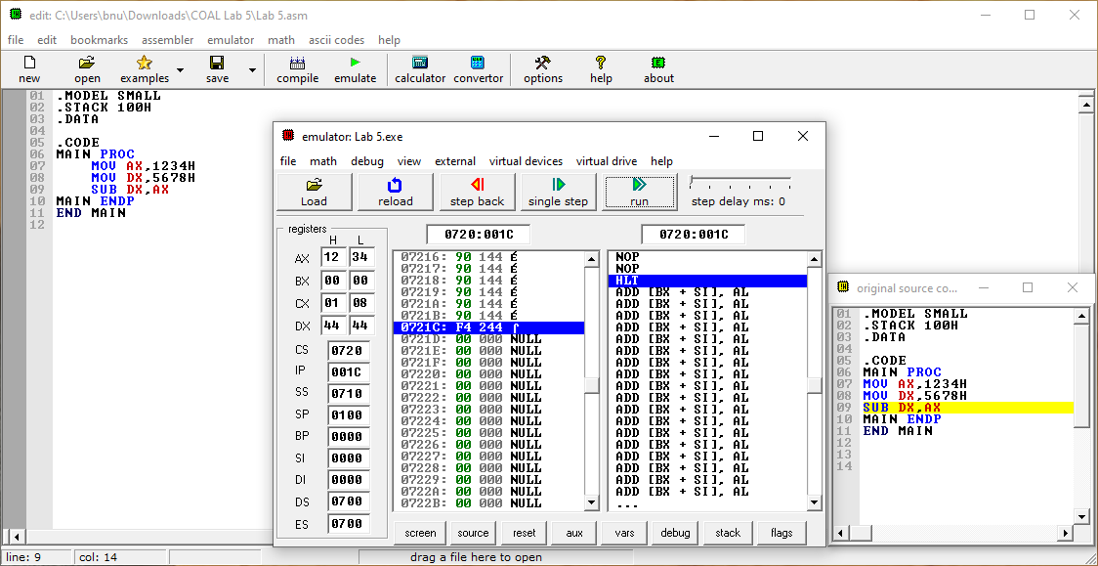

Problem No.2:
Subtract a memory value from a register &quot;Initialize the AX register with the immediate value 3000h. Store the value 1000h in memory. Subtract the memory value from AX and store the result in AX.

Solution:
.MODEL SMALL
.STACK 100H
.DATA

num1 DW 1000H

.CODE
MAIN PROC
MOV AX,3000H
MOV BX,OFFSET num1
MOV DX,[BX]
SUB AX,DX
MAIN ENDP
END MAIN
Screenshot:
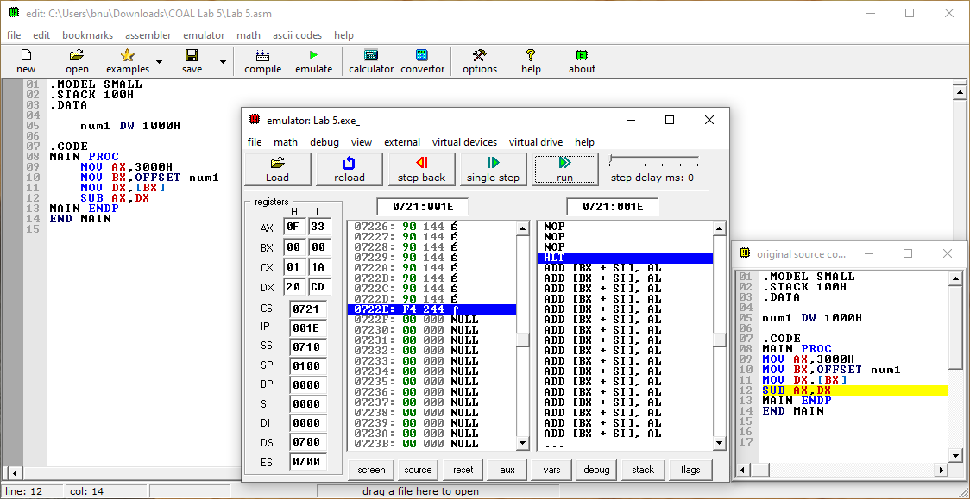

Problem No.3:
Store 6 in memory, initialize AX with 10, and multiply AX by the memory value.
Solution:
.MODEL SMALL
.STACK 100H
.DATA
num1 DW 6
.CODE
MAIN PROC
MOV AX,10
MOV BX,OFFSET num1
MOV CX, [BX]
MUL CX
MAIN ENDP
END MAIN
Screenshot:
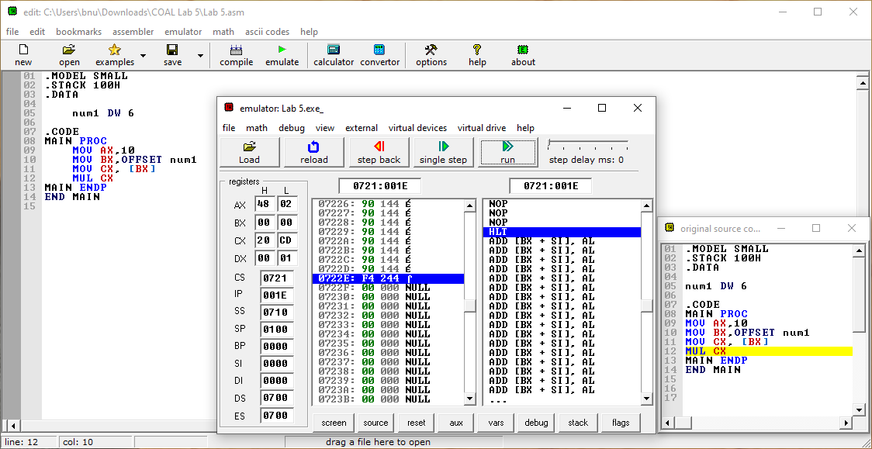

Problem No.4:
Initialize AL with -5 (FBh in hex) and BL with 3. Multiply them and store the result in AX.(Multiply Two Signed 8-bit Numbers ;use IMUL for signed numbers )
Solution:
.MODEL SMALL
.STACK 100H
.DATA

.CODE
MAIN PROC
MOV AL, -5
MOV BL, 3
IMUL BL

MOV AX, 4CH
INT 21H
MAIN ENDP
END MAIN
Screenshot:
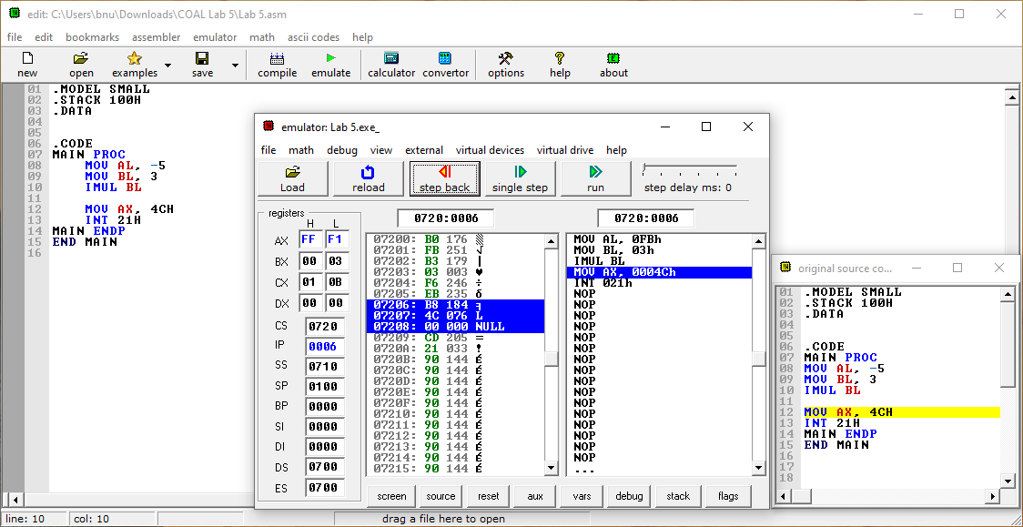

Problem No.5:
Write an assembly program that initializes AX with -25 (penalty amount) and multiplies it by 100h (256 months). Store the result in AX and determine the total amount deducted over this period.
Solution:
.MODEL SMALL
.STACK 100H
.DATA
result DW ? ; Reserve space to store the lower 16 bits of the result
highResult DW ? ; Reserve space to store the upper 16 bits of the result
.CODE
MAIN PROC
MOV AX, -25 ; Initialize AX with -25 (penalty amount)
MOV BX, 100h ; Initialize BX with 100h (256 months)
IMUL BX ; Multiply AX by BX, result is stored in DX:AX
MOV result, AX ; Store the lower 16 bits of the result in 'result'
MOV highResult, DX ; Store the higher 16 bits of the result in 'highResult'
MOV AH, 4CH ; DOS function to exit program
INT 21H
MAIN ENDP
END MAIN
Screenshot:
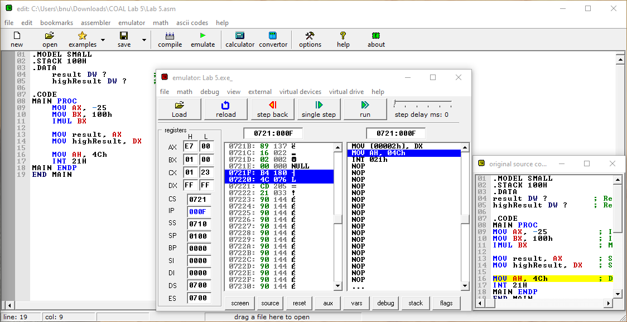

Problem No.6:
A system tries to divide 128 by -1 using 8-bit signed division (IDIV). However, this operation results in an overflow error because the quotient exceeds the 8-bit signed limit.
Solution:
.MODEL SMALL
.STACK 100H
.DATA
VAR1 DB 9
VAR2 DB 2
.CODE
MAIN PROC
MOV AX, @data
MOV DS, AX
MOV AX, 9
MOV bl, 2
DIV BL
MOV AH, 4CH
INT 21H
MAIN ENDP
END MAIN
Screenshot:
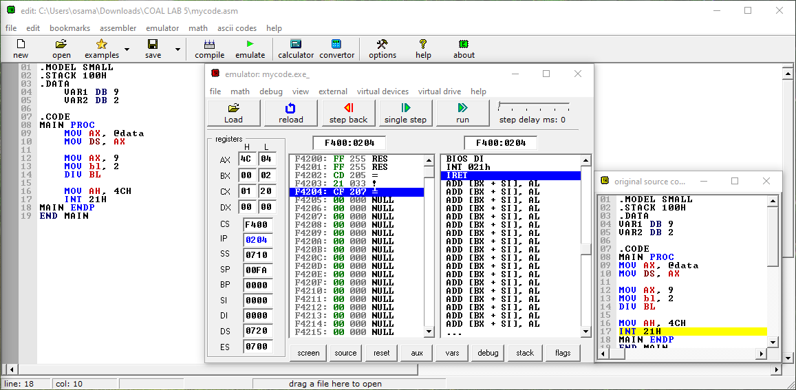
Problem No.7:
System is designed to split a 16-bit data value (5000h) into 8-bit chunks and store them in two different memory locations. Divide the 16-bit value by 100h,and store the higher 8-bit value in one location and the remainder in another.
Solution:
.MODEL SMALL
.STACK 100H
.DATA
VAR1 DW 5000H
.CODE
MAIN PROC
MOV AX, @data
MOV DS, AX
MOV DX, 0
MOV AX, VAR1
MOV CX, 100H
DIV CX
MOV AH, 4CH
INT 21H
MAIN ENDP
END MAIN
Screenshot:
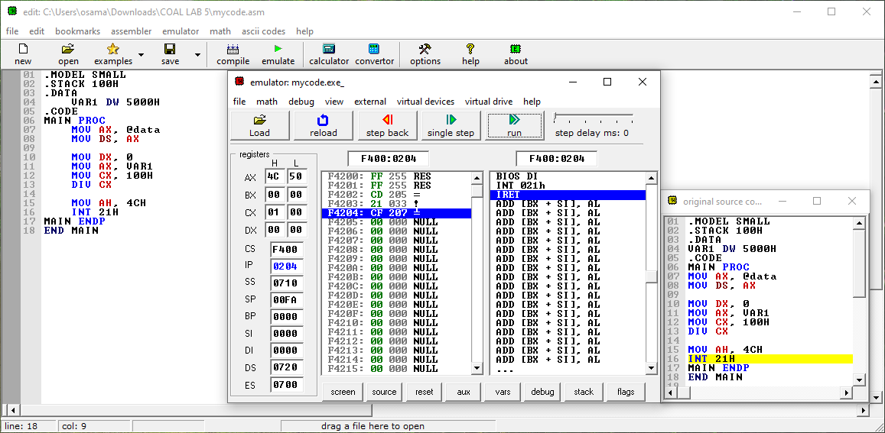

Problem No.8:
Lab Tasks: Addressing modes
- Move 200h into AX.
- Move 150h into BX.
- Move 25h to Memory Location at 200
- Move 15h to Memory Location at 250
- Introduce an Array num = { 2,1,0,0,1,3}
- Load AX with contents of memory location 200 using indirect addressing.
- Load CX with contents of memory location 250 using direct addressing.
- Define an array of num = { 2,1,0,0,1,3}and load the contents of the array in Ax using index addressing. [hint: array is defined as: num : db 2, 1 in the data section]
Solution:
.MODEL SMALL
.STACK 100H
.DATA
NUM DB 2,1,0,0,1,3 ; Array Num = (2,1,0,0,1,3)
.CODE
MAIN PROC
MOV AX, @DATA
MOV DS, AX

MOV AX, 200H
MOV BX, 150H

MOV [200H],25H
MOV [250H],15H

;Question a
MOV BX, 200H
MOV AL, [BX]

;Question b
MOV CX, [250H]

;Question c
MOV CX, 6
MOV SI, OFFSET NUM

HERE:
MOV DL, [SI]
ADD DL, 30H
MOV AH, 02H

INT 21H
INC SI

LOOP HERE
MOV AH, 4CH
INT 21H

MAIN ENDP
END MAIN
Screenshot:
